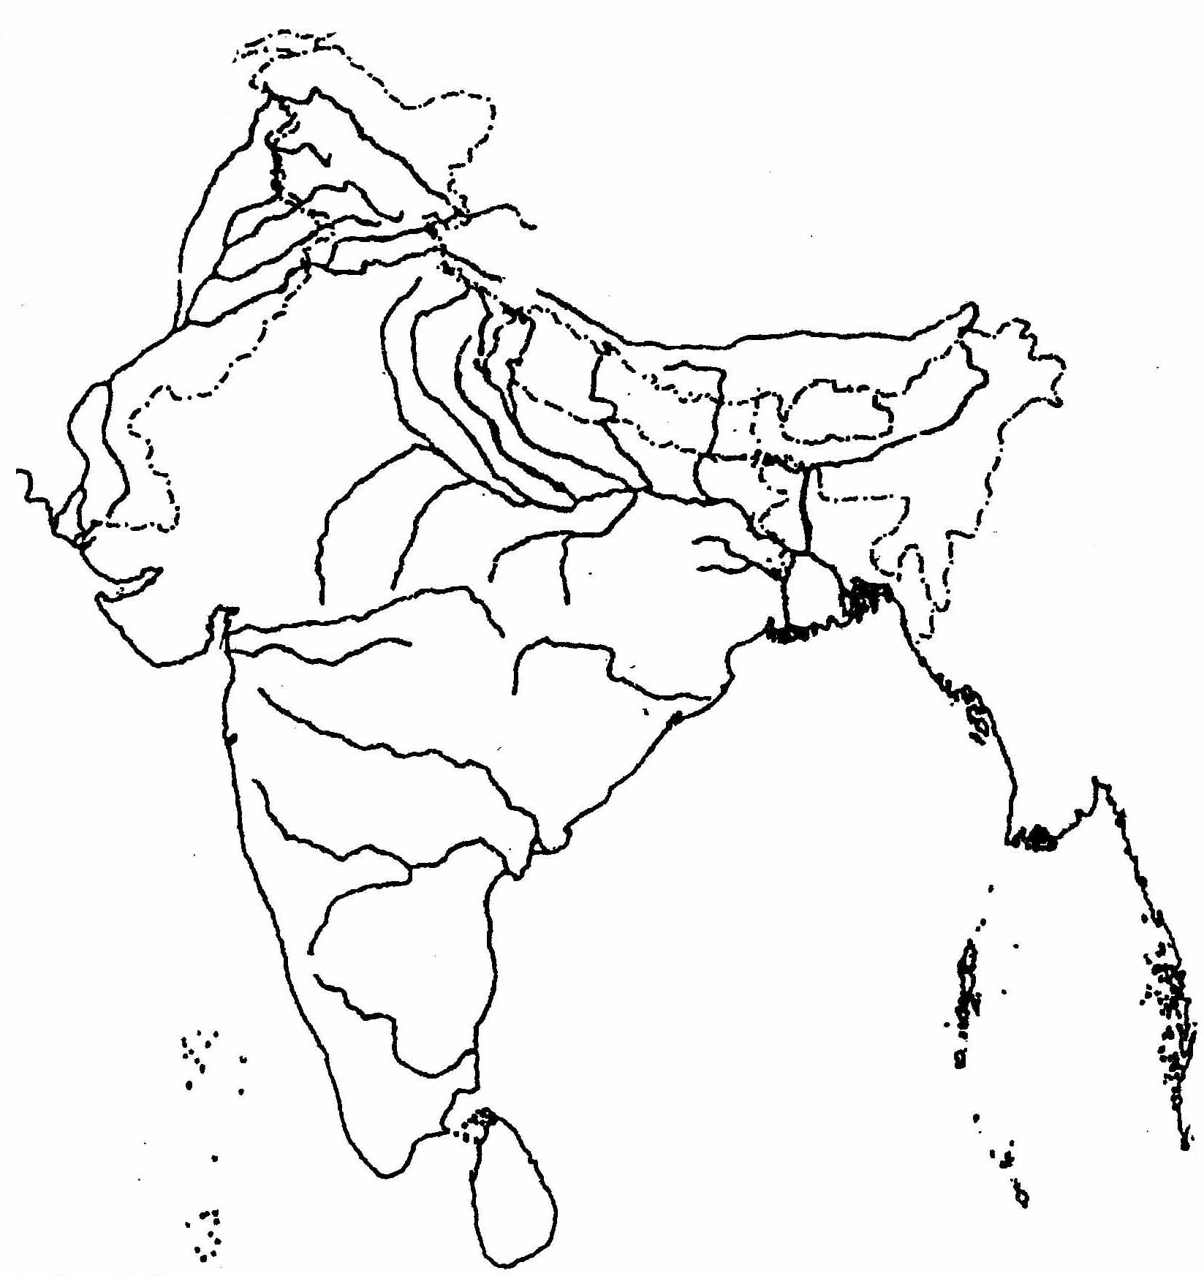
Jivaansh Yadav X-A 40
....................................................

